Title: Online Bus Ticket Booking System
Aim
To design and develop a responsive bus ticket booking website that allows users to register, search buses, book and cancel tickets, and post comments. It also enables the admin to manage bus details, categories, registered users, and generate reports.
Algorithm
- Start the application.
- Allow users to register and log in.
- Enter the source, destination, and journey date to search for buses.
- Display available buses, timings, and seats.
- Allow users to select seats, enter passenger details, and book tickets.
- Provide options to cancel tickets and post comments.
- Allow the admin to manage bus information, categories, users, and news.
- Generate reports and display booking details.
- Stop the application.
HTML Code

<!DOCTYPE html>
<html lang="en">
<head>
<meta charset="UTF-8">
<meta name="viewport" content="width=device-width, initial-scale=1.0">
<title>Online Bus Ticket Booking</title>
<style>
body {
font-family: Arial, sans-serif;
background: #f0f4f8;
margin: 0;
}
header {
background: #123b63;
color: white;
text-align: center;
padding: 20px;
}
main {
max-width: 600px;
margin: 25px auto;
padding: 20px;
background: white;
border-radius: 10px;
}
input, select, button {
width: 100%;
padding: 10px;
margin: 8px 0;
box-sizing: border-box;
}
button {
background: #087f8c;
color: white;
border: none;
cursor: pointer;
}
.bus {
background: #e0f2f1;
padding: 12px;
margin-top: 12px;
}
footer {
text-align: center;
padding: 15px;
}
</style>
</head>
<body>

<header>
<h1>Online Bus Ticket Booking</h1>
<p>Book Your Journey Easily</p>
</header>

<main>
<h2>Search Buses</h2>

<form id="busForm">
<label for="source">From:</label>
<input id="source" type="text" placeholder="Enter source" required>

<label for="destination">To:</label>
<input id="destination" type="text"
placeholder="Enter destination" required>

<label for="date">Journey Date:</label>
<input id="date" type="date" required>

<label for="category">Bus Category:</label>
<select id="category">
<option>Volvo AC</option>
<option>Sleeper Coach</option>
<option>Ordinary Coach</option>
</select>

<button type="submit">Search Buses</button>
</form>

<div id="result"></div>

<h2>Comments</h2>
<input type="text" id="comment" placeholder="Enter your comment">
<button type="button" onclick="addComment()">Post Comment</button>
<p id="commentResult"></p>

<h2>Admin Information</h2>
<p>Admin can manage bus details, categories, users, and reports.</p>
</main>

<footer>
<p>&copy; 2026 Online Bus Booking System</p>
</footer>

<script>
document.getElementById("busForm").addEventListener("submit", function(e) {
e.preventDefault();

let source = document.getElementById("source").value;
let destination = document.getElementById("destination").value;
let date = document.getElementById("date").value;
let category = document.getElementById("category").value;

if (source.toLowerCase() === destination.toLowerCase()) {
document.getElementById("result").textContent =
"Source and destination must be different.";
return;
}

document.getElementById("result").innerHTML = `
<div class="bus">
<h3>Available Bus (Demo)</h3>
<p>Route: ${source} to ${destination}</p>
<p>Date: ${date}</p>
<p>Category: ${category}</p>
<p>Available Seats: 30</p>
<p>Fare: ₹500 (Demo)</p>
<button type="button" onclick="alert('Demo only: no ticket booked.')">
Book Ticket
</button>
</div>`;
});

function addComment() {
let comment = document.getElementById("comment").value.trim();
document.getElementById("commentResult").textContent =
comment ? "Comment posted: " + comment : "Please enter a comment.";
}
</script>

</body>
</html>
Output:
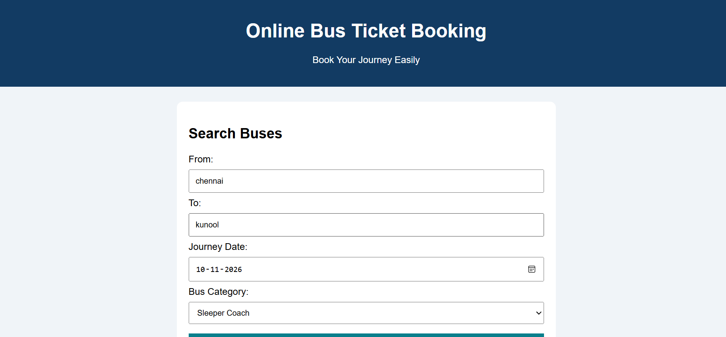
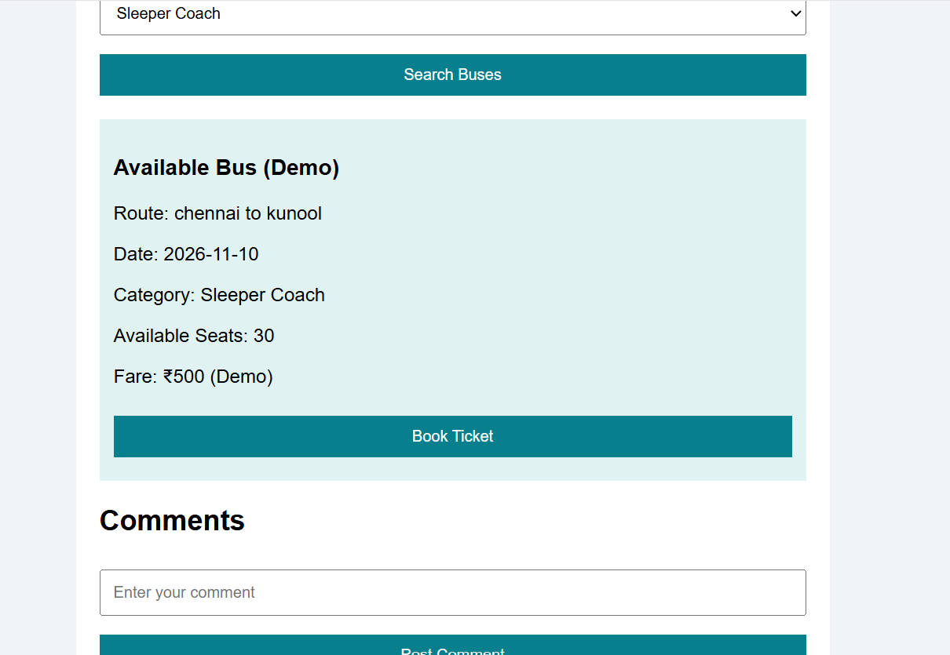
Result
The Online Bus Ticket Booking webpage was created successfully. Users can enter journey details, search for buses, view sample bus information, and post comments. The admin functions are described on the webpage but require backend development for actual management.

